GenAI
UNIT 1 Hands-On 1 Observations
Generative AI & NLP Fundamentals

NAME: Asmi Vishal Kapadnis
SRN: PES2UG23CS100
SECTION: B

Part 1: Introduction to Hugging Face and Transformers Library
What is Hugging Face?
Hugging Face is often called the "GitHub of AI". It is a massive repository where researchers and companies share their trained models, datasets, and demos. Instead of training a model from scratch (which costs millions of dollars), we can download models like GPT-2, BERT, or RoBERTa directly from Hugging Face and use them.
What is the transformers library?
The transformers library is the bridge between the models on Hugging Face and your code. It provides APIs to easily download, load, and run state-of-the-art pretrained models. It supports framework interoperability, meaning you can often move between PyTorch, TensorFlow, and JAX.
What is pipeline()?
The pipeline() function is the most powerful high-level tool in the library. It abstracts away the complex math and processing into three simple steps:
- Preprocessing: Converts your raw text into numbers (Tokens & IDs) that the model can understand.
- Model Inference: The model processes the numbers and outputs predictions (logits).
- Post-processing: The raw predictions are converted back into human-readable text (labels, answers, summaries).
With just one line, pipeline('task-name') handles all of this for you.
Observations:
- Hugging Face democratizes AI by providing free access to pre-trained models, eliminating the need for expensive infrastructure and training.
- The transformers library simplifies complex NLP tasks through high-level abstractions like pipeline().
- Framework interoperability allows developers to work with their preferred deep learning framework without being locked into a single ecosystem.

Part 2: Generative AI - Dumb vs. Smart Models
Concept:
Generative AI creates new content (text, images, audio). The quality depends heavily on the model's size and training. We compared two models:
- distilgpt2: A 'distilled' version - smaller, faster, requires less memory, but might be less coherent (a "Dumb" model for this comparison).
- gpt2: The standard version (The "Smart" model, though still small by modern standards).
Step 1: Set a Seed
A seed value is used to make random results reproducible. When we set a seed, the random number generator starts from the same point each time, producing the same sequence of random values.
Code:


Step 2: Define a Prompt
Both models will complete this sentence:
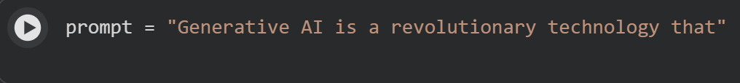
Step 3: Fast Model (distilgpt2)
Code:
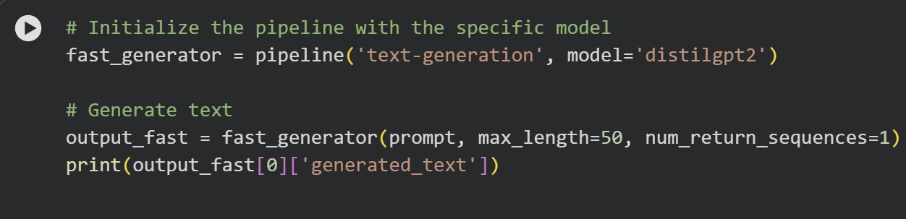
Output (Seed = 42):
Generative AI is a revolutionary technology that can take on the task of finding, learning, and learning in a given environment.
Output (Seed = 68):
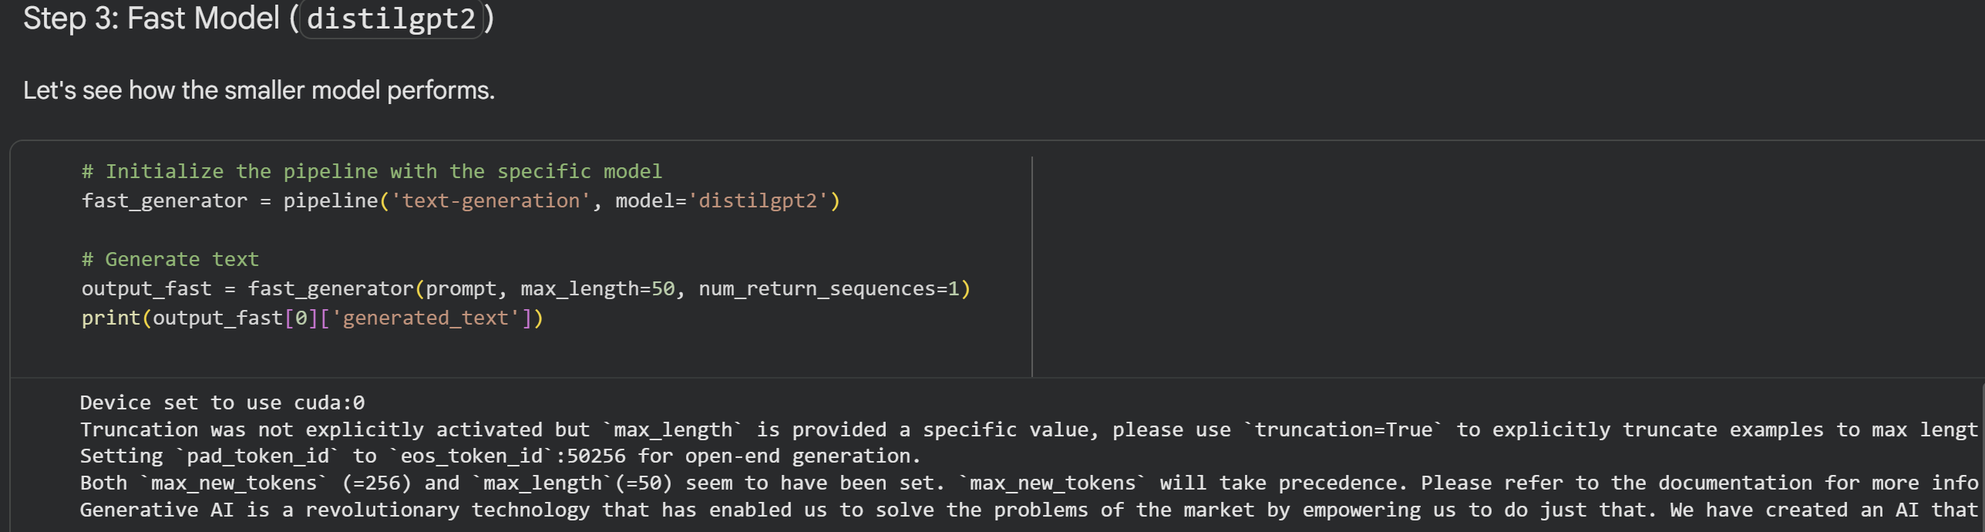
Generative AI is a revolutionary technology that has enabled us to solve the problems of the market by empowering us to do just that. We have created an AI that can solve the problems of the market by empowering us to do just that. We have created an AI that can solve the problems of the market by empowering us to do just that. We have created an AI that can solve the problems of the market by empowering us to do just that. We have created an AI that can solve the problems of the market by empowering us to do just that.
Step 4: Standard Model (gpt2)
Code:
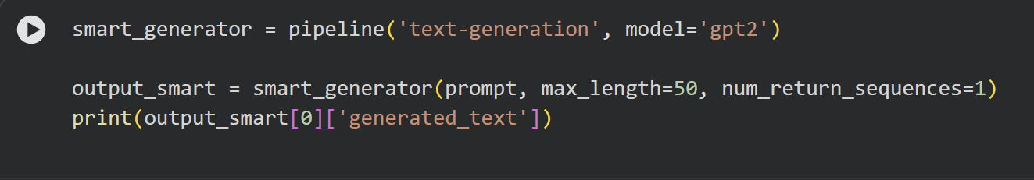
Output (Seed = 42):
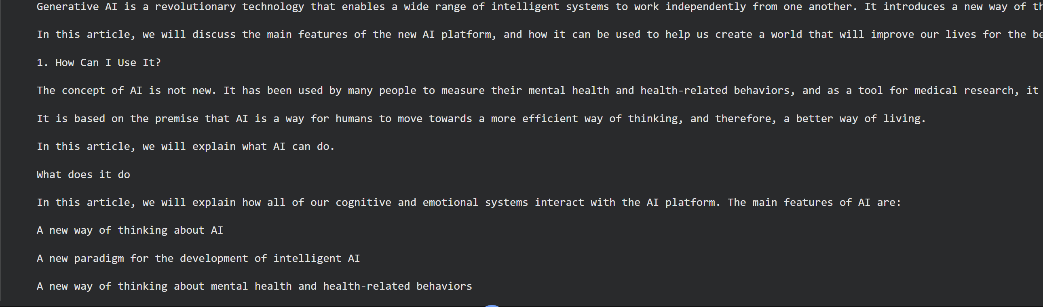
Generative AI is a revolutionary technology that enables a wide range of intelligent systems to work independently from one another. It introduces a new way of thinking about AI and provides a new paradigm for the development of intelligent AI.
In this article, we will discuss the main features of the new AI platform, and how it can be used to help us create a world that will improve our lives for the better.
1. How Can I Use It?
The concept of AI is not new. It has been used by many people to measure their mental health and health-related behaviors, and as a tool for medical research, it has been used by many of us to track and report on our mental health.
It is based on the premise that AI is a way for humans to move towards a more efficient way of thinking, and therefore, a better way of living.
In this article, we will explain what AI can do.
What does it do
In this article, we will explain how all of our cognitive and emotional systems interact with the AI platform. The main features of AI are:
A new way of thinking about AI
A new paradigm for the development of intelligent AI
A new way of thinking about mental health and health-related behaviors
Observations:
- Impact of Seed Values:
- Same seed = Same output: Using seed = 42 consistently produces the same text across multiple runs, demonstrating reproducibility.
- Different seed = Different output: Changing the seed to 68 produces entirely different text, showing the stochastic (random) nature of text generation.
- Model Comparison - distilgpt2 vs. gpt2:
- distilgpt2 (Fast Model):
  - Output with seed 42 is relatively coherent but generic and somewhat repetitive ("finding, learning, and learning").
  - Output with seed 68 shows severe repetition issues - the same phrase repeats multiple times, demonstrating the model's tendency to drift into nonsensical loops.
  - The model is faster and more memory-efficient but compromises on quality.
- gpt2 (Standard Model):
- Produces significantly more coherent and contextually relevant output.
- Stays on topic and provides a logical flow of ideas about AI applications.
- Demonstrates better understanding of context and generates more meaningful content.
- While still small by modern standards, it clearly outperforms the distilled version in quality.
- Architecture Note: GPT-2 is a decoder-only model, meaning it only has the decoder part of the Transformer architecture, specialized for text generation tasks.
- Temperature and Randomness:
- Although not explicitly set in this code, temperature is a hyperparameter that controls randomness in text generation.
- Higher temperature = More randomness: The model takes more creative risks, potentially producing diverse but less predictable outputs.
- Lower temperature = Less randomness: The model produces more conservative, predictable outputs.
Key Takeaway:
The standard gpt2 model stays more on topic and maintains coherence, while the fast distilgpt2 model tends to drift into repetitive or nonsensical patterns, especially visible with seed 68. This demonstrates the trade-off between model efficiency (speed/memory) and output quality.

Part 3: NLP Fundamentals - Under the Hood
3.1 Tokenization
- Why? Models cannot read English strings. They only understand numbers.
- What? Tokenization breaks text into pieces (Tokens) and assigns each piece a unique ID.

Code:
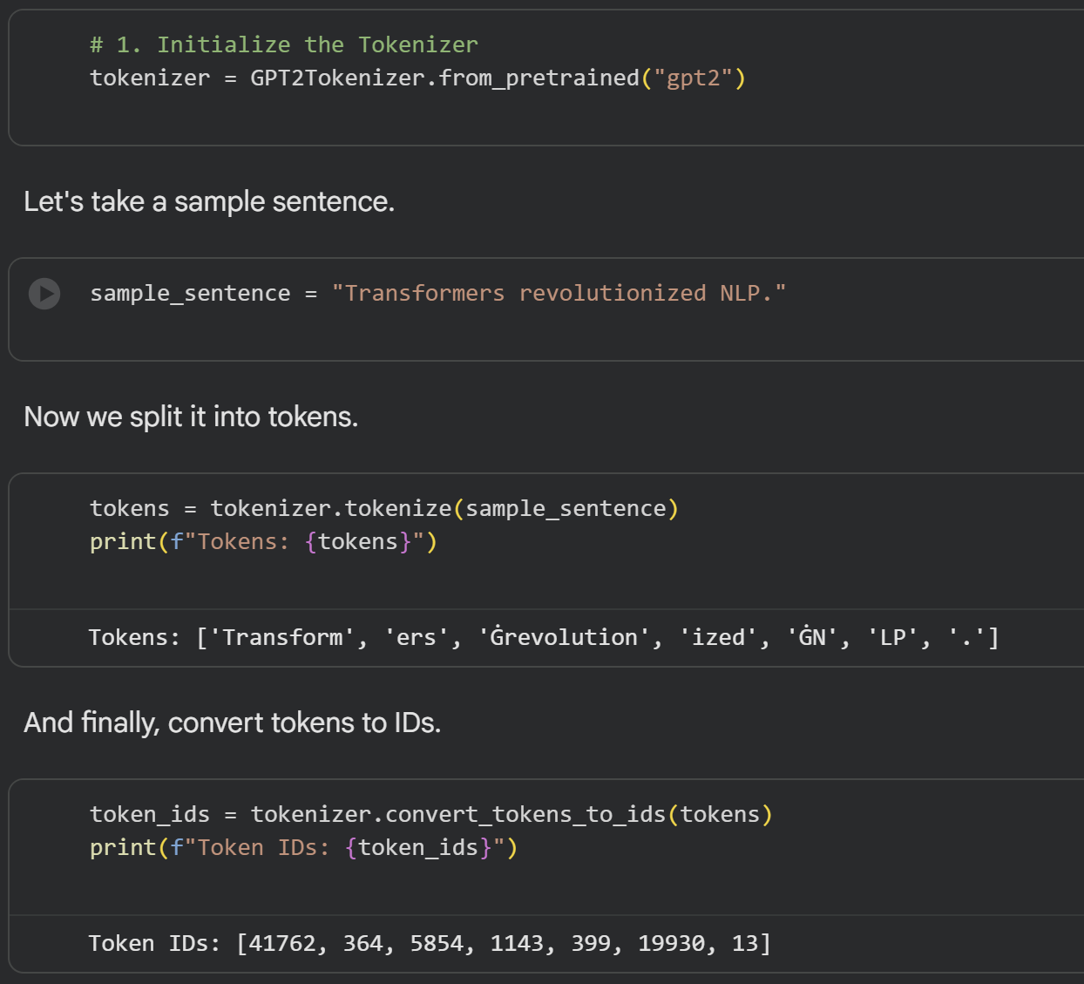
Observations:
- Subword Tokenization:
- The sentence is broken into subword units, not just whole words.
- "Transformers" → ['Transform', 'ers']
- "revolutionized" → ['Ġrevolution', 'ized']
- The 'Ġ' symbol represents a space before the token.
- Why Subword Tokenization?
- Handles rare or unseen words by breaking them into known subwords.
- Reduces vocabulary size while maintaining flexibility.
- GPT-2 uses Byte-Pair Encoding (BPE) tokenization.
- Different Models, Different Tokenizers:
- Each model has its own tokenizer because each model is trained with a different architecture and vocabulary.
- GPT-1 and GPT-2 will have different tokenizers despite being similar architectures.
- The tokenizer must match the model for proper functioning.
- Types of Tokenization:
- Word-level: Splits text into complete words (simple but large vocabulary).
- Character-level: Splits text into individual characters (small vocabulary but very long sequences).
- Subword-level (BPE, WordPiece, SentencePiece): Balances vocabulary size and sequence length - used by GPT-2, BERT, etc.
Key Takeaway:
Tokenization converts human-readable text into numerical representations that neural networks can process. GPT-2 uses BPE tokenization, which breaks words into subword units for better handling of rare words and efficient vocabulary management.

3.2 POS Tagging (Part-of-Speech)
Why? To understand grammar. Is 'book' a noun (the object) or a verb (to book a flight)?
What? We label each word as Noun (NN), Verb (VB), Adjective (JJ), etc.
Code:
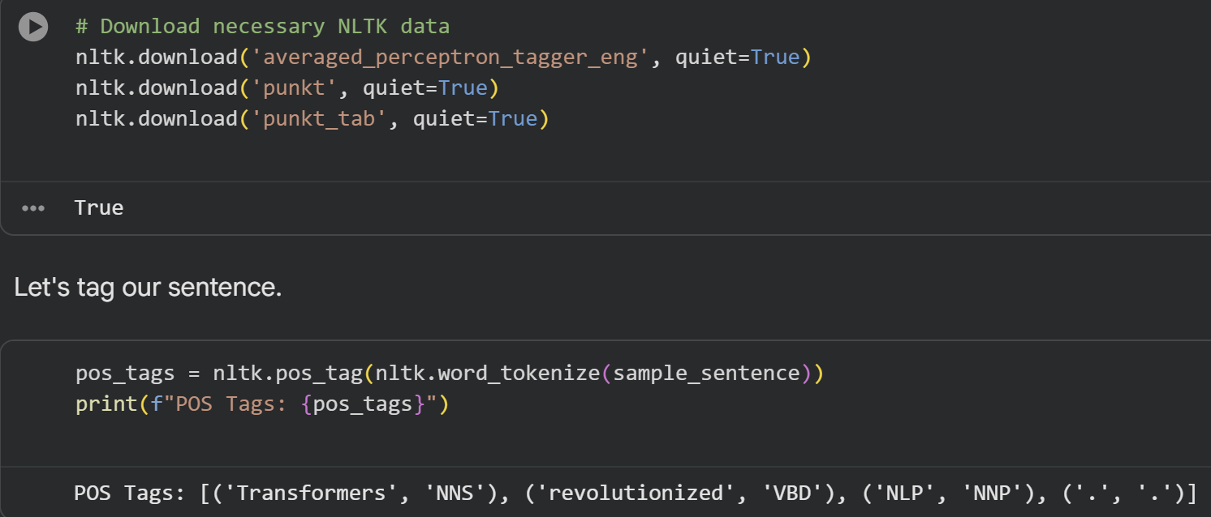
Observations:
- POS Tags Explained:
- NNS: Plural noun (Transformers)
- VBD: Past tense verb (revolutionized)
- NNP: Proper noun, singular (NLP)
- .: Punctuation mark
- Why POS Tagging Matters:
- Helps models understand grammatical structure and relationships.
- Enables pattern recognition (e.g., adjectives typically come before nouns).
- Assists in disambiguating word meanings based on context.
- Different POS Tag Sets:
- Penn Treebank tags (used here): Most common, with 36 tags.
- Universal POS tags: Simplified set with 17 tags for cross-language compatibility.
- Different models may use different POS representations based on their training data.
Key Takeaway:
POS tagging adds grammatical context to words, helping models understand sentence structure and word relationships. This is crucial for tasks like parsing, translation, and semantic analysis.

3.3 Named Entity Recognition (NER)
Why? To extract structured information like names, organizations, and dates.
What? We use a specific BERT model fine-tuned for the NER task.
Code:
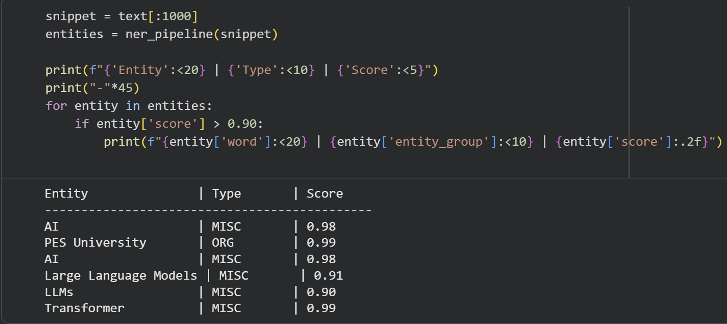
Observations:
- Entity Types Identified:
- MISC (Miscellaneous): AI, Large Language Models, LLMs, Transformer - technical terms and concepts.
- ORG (Organization): PES University - institutional name.
- Confidence Scores:
- All identified entities have scores > 0.90, indicating high confidence.
- "PES University" has the highest score (0.99), as organizational names are typically easier to identify.
- Why Use BERT for NER?
- BERT = Bidirectional Encoder Representations from Transformers
- Encoder-only model: Designed to understand sentences, not generate them.
- Bidirectional reading: BERT reads text from both left-to-right and right-to-left simultaneously.
- Example: "Apple is my favorite fruit."
  - Reading left-to-right alone doesn't help the model understand immediately if "Apple" refers to the fruit or the company.
  - BERT reads the entire sentence from both directions to get full context before making predictions.
- NER Workflow:
- NER tries to understand and recognize what a particular word or phrase represents in the real world.
- It categorizes entities into predefined classes: PERSON, ORGANIZATION, LOCATION, DATE, etc.
- Useful for information extraction, document classification, and knowledge graph construction.
Key Takeaway:
NER extracts meaningful entities from unstructured text by identifying and classifying named entities. BERT's bidirectional architecture makes it particularly effective for this task as it considers full context from both directions.

Part 4: Advanced Applications - Comparative Analysis
4.1 Summarization: Efficiency vs. Quality
We summarize a complex section about Transformer Architecture using two models:
- distilbart-cnn-12-6: Optimized for speed (Fast Summarizer)
- bart-large-cnn: Optimized for performance (Quality Summarizer)
Fast Summarizer Output (distilbart-cnn-12-6):
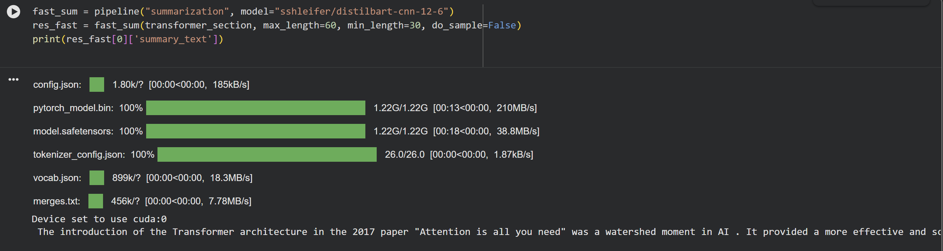
The introduction of the Transformer architecture in the 2017 paper "Attention is all you need" was a watershed moment in AI. It provided a more effective and scalable way to handle sequential data like text, replacing older, less efficient methods like recurrence (RNNs) and conv
Quality Summarizer Output (bart-large-cnn):
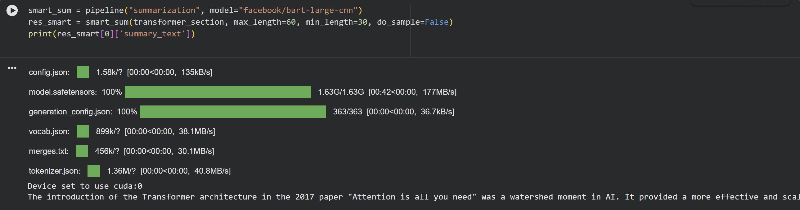
The introduction of the Transformer architecture in the 2017 paper "Attention is all you need" was a watershed moment in AI. It provided a more effective and scalable way to handle sequential data like text.
Observations:
- Fast vs. Quality Trade-off:
- Fast Summarizer: The output is cut off mid-word ("conv"), indicating potential truncation issues or less refined post-processing.
- Quality Summarizer: Produces a complete, grammatically correct summary with proper sentence closure.
- Why BART for Summarization?
- BART = Bidirectional and Auto-Regressive Transformers
- Has both encoder (to read and understand the input) and decoder (to write the summary).
- This encoder-decoder architecture is ideal for sequence-to-sequence tasks like summarization, translation, and paraphrasing.
- Encoder-Decoder Architecture:
- Encoder: Processes the entire input text to understand its meaning and context.
- Decoder: Generates the summary word-by-word based on the encoder's understanding.
- Multi-head attention allows the model to focus on different parts of the input simultaneously.
Key Takeaway:
Quality summarization requires both understanding (encoder) and generation (decoder) capabilities. While the fast model is efficient, the quality model produces more reliable and complete summaries. BART's encoder-decoder architecture makes it well-suited for abstractive summarization tasks.

4.2 Question Answering
This task is Extractive QA - we provide a context (our text) and a question. The model highlights the answer within the text.
Code:
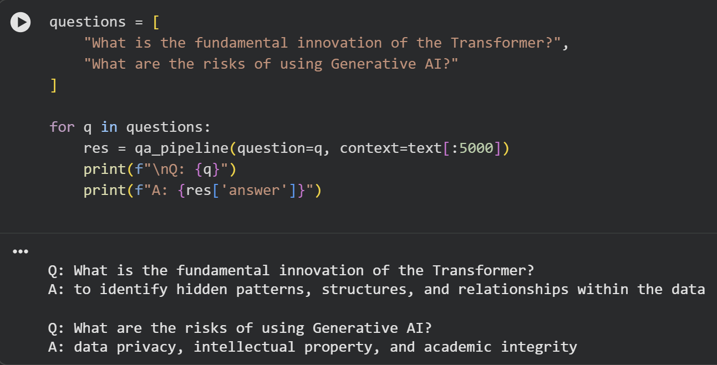
Observations:
- Extractive QA:
- The model doesn't generate new text; it extracts the answer directly from the provided context.
- Answers are word-for-word spans from the input text.
- Model Used: DistilBERT
- A distilled (smaller, faster) version of BERT.
- Fine-tuned on the SQuAD (Stanford Question Answering Dataset).
- Maintains most of BERT's performance while being more efficient.
- How It Works:
- The model reads both the question and the context.
- It identifies the most relevant span of text that answers the question.
- Returns the answer along with a confidence score.
- Limitations:
- Can only extract answers present in the context.
- Cannot synthesize information from multiple parts of the text.
- Cannot answer questions requiring external knowledge.
Key Takeaway:
Extractive QA models like DistilBERT locate and extract answers from given text rather than generating new responses. This is useful for finding specific information in documents but is limited to what's explicitly stated in the context.

4.3 Masked Language Modeling (Fill-in-the-Blank)
This is the core training objective of BERT. We hide a token ([MASK]) and ask the model to predict it based on context.
Code:
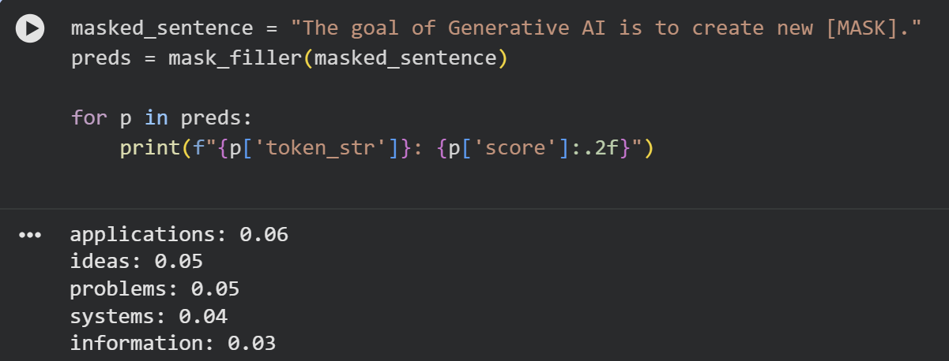
Observations:
- Masked Language Modeling (MLM):
- BERT's pre-training task where random words are masked, and the model learns to predict them.
- Forces the model to learn bidirectional context - understanding what comes before AND after the mask.
- Predictions:
- The model suggests multiple possibilities with probability scores.
- "applications" has the highest probability (0.06), which makes sense in the context of Generative AI.
- Other reasonable predictions include "ideas," "problems," "systems," and "information."
- Why Bidirectional Context Matters:
- The model uses both the words before ("The goal of Generative AI is to create new") and after (".") to make predictions.
- This bidirectional understanding helps disambiguate meanings and make contextually appropriate predictions.
- BERT's Architecture:
- Encoder-only model with both reading capabilities (encoder) and understanding from both directions.
- Unlike GPT (decoder-only, left-to-right), BERT processes entire sentences simultaneously.
- This makes BERT excellent for understanding tasks (classification, NER, QA) but not for generation.
Key Takeaway:
Masked Language Modeling teaches BERT to understand context by predicting masked words using bidirectional information. This pre-training approach enables BERT to excel at understanding-based NLP tasks.

THE MODEL BENCHMARK CHALLENGE

The Models:
- BERT (Bidirectional Encoder Representations from Transformers)
- Architecture: Encoder-only
- How it works: Reads text bidirectionally (looks at words before AND after)
- Trained for: Masked Language Modeling (predicting hidden words)
- Best at: Understanding text, classification, fill-in-the-blank tasks
- Can't do: Generate new text from scratch
- RoBERTa (Robustly Optimized BERT)
- Architecture: Encoder-only (like BERT but better trained)
- How it works: Same as BERT but with more data and longer training
- Trained for: Masked Language Modeling (improved version)
- Best at: Same as BERT but slightly better performance
- Can't do: Generate new text from scratch
- BART (Bidirectional and Auto-Regressive Transformers)
- Architecture: Encoder-Decoder
- How it works: Encoder understands input, decoder generates output
- Trained for: Denoising (reconstructing corrupted text)
- Best at: Translation, summarization, generation (when fine-tuned properly)
- Can do: Both understanding AND generation tasks

Experiment 1: Text Generation
Task: Continue the text: "The future of Artificial Intelligence is..."
Model | Output | Success/Failure | Why?
BERT | Just dots: "........" | Failure | Encoder-only - can't predict next words, not designed for generation
RoBERTa | Just repeated input | Failure | Same as BERT - encoder-only architecture lacks generation ability
BART | Random gibberish: "patrons Ole flush demonstrate nurture..." | Failure | Has right architecture BUT not trained for free-form generation. Needs fine-tuning

Experiment 2: Fill-Mask (Predict Missing Word)
Task: "The goal of Generative AI is to ____ new content."
Model | Top Predictions | Success/Failure | Why?
BERT | 'create' (54%), 'generate' (16%), 'produce' (5%) | Success | This is EXACTLY what BERT was trained for - predicting masked words
RoBERTa | 'generate' (37%), 'create' (37%), 'discover' (8%) | Success | Same training as BERT but optimized - performs excellently
BART | 'create' (7%), 'help' (7%), 'provide' (6%) | Partial Success | Can do it but lower confidence - not its main training focus

Experiment 3: Question Answering
Task: "What are the risks?"
Context: "Generative AI poses significant risks such as hallucinations, bias, and deepfakes."
Model | Answer | Confidence | Success/Failure | Why?
BERT | ", and deepfakes" | 0.7% | Failure | Has right architecture but NOT fine-tuned for QA - just guessing
RoBERTa | "Generative AI poses significant risks such as hallucinations, bias," | 0.9% | Failure | Same as BERT - needs QA-specific fine-tuning to work properly
BART | "deepfakes." | 5.3% | Failure | Partially correct but still very low confidence - not designed for extractive QA

Key Takeaways
Architecture Types:
- Encoder-only (BERT, RoBERTa): Great for understanding, terrible for generation
- Encoder-Decoder (BART): Can do both but needs proper training/fine-tuning
- Decoder-only (GPT - not tested): Best for generation

Why Models Failed:
- Text Generation: BERT/RoBERTa lack generation architecture; BART lacks generation training
- Fill-Mask: All succeeded, but BERT/RoBERTa best because it's their core training task
- Question Answering: All failed because base models aren't fine-tuned for QA

Observation Table:
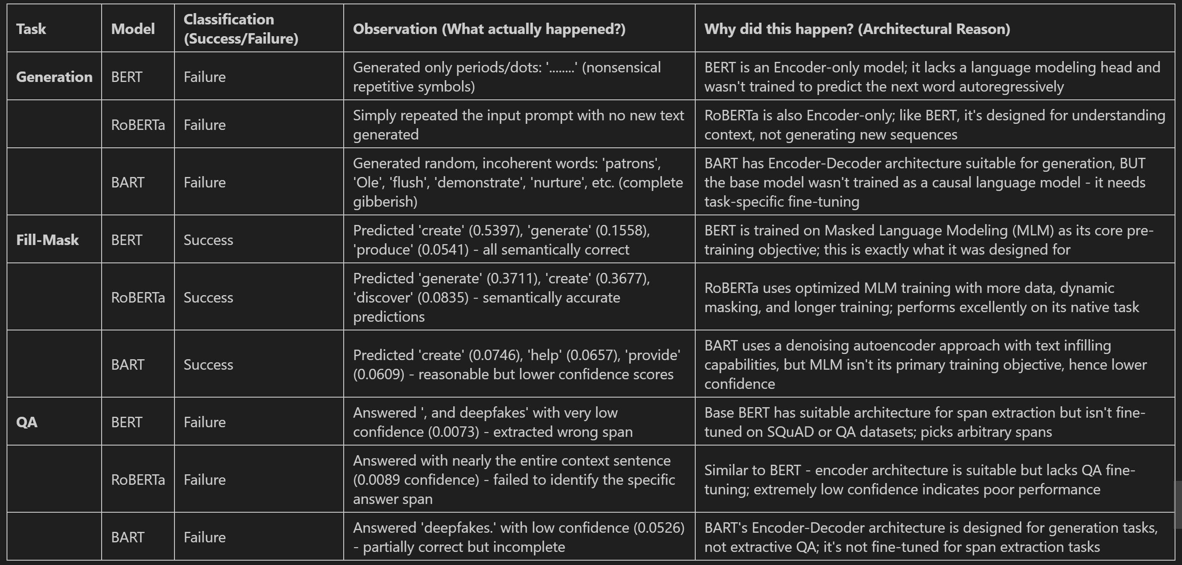

GenAI & NLP Project Ideas with HF Models
Category 5: Optimization & Tools (The "Utility" Agents)
Grammar & Spell Fixer

What is this tool?
A grammar correction system using BERT's fill-mask capability to predict and fix incorrect words in sentences.

How does it work?
- Input: A sentence with a grammatical error
- Masking: Replace the incorrect word with [MASK]
- Prediction: BERT predicts the most likely correct word based on context
- Output: Corrected sentence with the best prediction

Technology Used
- Model: bert-base-uncased with pipeline('fill-mask')
- Why BERT? It was trained on Masked Language Modeling (MLM) - predicting missing words is its core strength
- Confidence Scores: Higher scores = more certain the prediction is correct

Test Results
- Test 1: Verb Form Error
- Original: "I am go to school"
- Error: Wrong verb form ("go" should be "going")
- Corrected: "I am going to school"
- Confidence: 78% - Very confident prediction
- Test 2: Preposition Error
- Original: "I am good in math"
- Error: Wrong preposition ("in" should be "at")
- Corrected: "I am good at math"
- Confidence: 97.2% - Extremely confident (near perfect)
- Test 3: Article Error
- Original: "I saw a elephant"
- Error: Wrong article ("a" should be "an" before vowel)
- Corrected: "I saw an elephant"
- Confidence: 71.4% - High confidence

Key Observations
- What Works Well:
- Fixing verb forms (go -> going)
- Correcting prepositions (in -> at)
- Fixing articles (a -> an)
- High confidence scores show BERT understands grammar rules
- Limitations:
- Manual masking required: You must know which word is wrong and mask it yourself
- One word at a time: Can only fix one error per run
- No automatic detection: Doesn't automatically find errors in sentences
- Context dependent: Works best with clear grammatical patterns

